Vacuum Delay on Stealth 20B/BT before serial number beginning 21500000

To disable vacuum on until key off feature when squeegee is raised, locate jumper on relay board labeled ECB
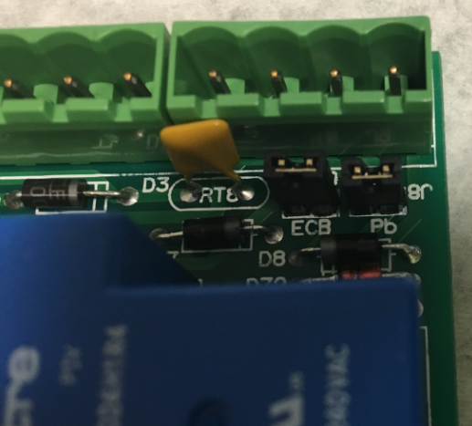
Remove Jumper
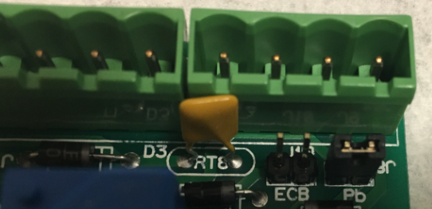
Vacuum Motor will now turn off as soon as the squeegee is lifted off of the floor

